Integrazione e Immigrazione come politiche per la natalità
Integration and immigration as policies to boost birth rates

Demographic Projections and Migration Policy for Italy
Final report
May 2026
Andrea Ballerini, Nicolò Cavalli, and Dev Srivastava,
with valuable support from Giovanni Cresti

1. Our Project, Scenarios, and Research Question
This project studies how the transformation of Italy’s age structure affects births and evaluates whether immigration and integration can work as complementary demographic policy tools. The starting point is that Italy’s demographic decline cannot be understood only through the total fertility rate. TFR measures fertility intensity, but the number of births also depends on the number and age distribution of potential parents. When the cohorts entering reproductive ages are small, even a recovery in fertility may produce only a limited increase in births. For this reason, the project focuses on the structural side of the demographic process: the size and composition of the population by age. The empirical core of the project is a cohort-component population projection for Italy under alternative migration scenarios.
The project has three core aims. First, it reconstructs the evolution of the number of potential parents over time by age and sex. Second, it builds alternative migration scenarios that differ in both the total number of immigrants and the age profile of inflows. Third, it discusses policy levers that can increase the number of potential parents, combining immigration levels, selective age profiles, family composition, and stronger social and civic integration.
The project works with three main migration scenarios and one reverse-policy calculation:
Scenario | Definition in the project
Scenario 1: baseline | Migration continues according to the internally forecast baseline path for immigration and emigration, using the current/recent age-sex-origin structure as the reference.
Scenario 2: policy on levels | The total number of immigrants is increased, while the baseline age-sex-origin structure is kept fixed.
Scenario 3: targeted policy | The total number of immigrants is increased, and the age structure is shifted toward younger adult ages and children, representing a policy oriented to potential parents and families.
Reverse policy calculation | The tool can also solve for how many additional immigrants per year are needed to reach a selected population or OADR target. This is used in addition to forward scenario simulation, not instead of it.
Table 1: Our Scenarios
The research question is: under the two policy-oriented scenarios, how many immigrants would be required to reduce depopulation pressure and keep the old-age dependency ratio below a chosen threshold? Operationally, we treat this also as an inverse problem: in addition to fixing migration assumptions and observing outcomes, the tool can solve for the migration level and profile required to approach defined targets.

2. State of the Art: What ISTAT and UN Do

2.1 ISTAT
ISTAT population projections are produced using the cohort-component method, where the future population is obtained by projecting fertility, mortality and international migration and applying them to the population by age and sex.
Fertility
Regional fertility projections are based on fertility intensity and age schedule of fertility.
The total fertility rate (TFR) is forecast using ARIMA time-series models estimated on historical data (1977–2021). The model most frequently used is ARIMA (2,0,0) with intercept, estimated separately for each region.
The age pattern of fertility is modelled using the quadratic spline model proposed by Schmertmann. This approach represents the standardized age-specific fertility curve through three parameters:
- $α:$ age at the beginning of the reproductive schedule;
- $P:$ age at peak fertility;
- $H:$ age after the peak at which fertility declines to half of the maximum level.
The quadratic spline model fits five second-degree polynomials to the fertility schedule. The resulting function is continuous with a continuous first derivative and is uniquely determined by the parameter vector $[α, P, H].$
Forecasting age-specific fertility rates therefore reduces to forecasting the three parameters of the model using ARIMA processes estimated on historical data.
Mortality
Mortality projections are produced using the Lee-Carter model in the Lee–Miller variant. In this formulation the logarithm of the age-specific death probabilities is approximated using three parameters:
$$ln(q_{x}\left(t\right))=a\left(x\right)+b\left(x\right)k\left(t\right)$$
where
- $a(x)$ represents the average age pattern of mortality;
- $b\left(x\right)$ represents the sensitivity of mortality at age x to changes in the mortality index;
- $k(t)$ represents the overall mortality trend over time.
In the Lee–Miller version used by ISTAT, the adjustment procedure ensures that the fitted mortality schedule reproduces the observed life expectancy at birth, rather than the total number of deaths as in the original Lee-Carter formulation.
Future mortality levels are obtained by projecting the time index $k(t)$, estimated on the period 1974–2021, using a random walk with drift. The parameters $a(x)$ and $b(x)$ are initially kept constant over time.
International migration
Projections of international migration flows are constructed using a deterministic intermediate model based on recent observations.
The total number of immigrants and emigrants in the first projection year is set equal to the average observed during the most recent five valid years (2016–2019 and 2021). Over the projection horizon, immigration and emigration totals are assumed to converge gradually to the same level, corresponding to the initial semi-sum of the two flows.
The age-sex distribution of migration flows is obtained using the Castro–Rogers model. This model represents the typical age profile of migration as a mathematical function composed of several additive components and up to eleven parameters. These parameters are estimated using the observed migration flows in 2016–2019 and 2021 through nonlinear regression and are kept constant during the projection period, implying that overall migration level may change over time while the age distribution remains fixed.

2.2 United Nations
The UN produces projections with a cohort-component framework using single years of age and annual time steps, starting from 1 January 2024 and projecting forward to 2101. The UN uses probabilistic methods to generate many trajectories for the key drivers: TFR, life expectancy at birth, and total net migration.
Fertility
TFR is projected probabilistically using a Bayesian hierarchical model built around a double-logistic representation of fertility decline. In practice, the UN generates large samples of double-logistic curves (via MCMC), then produces a set of projected TFR trajectories to represent uncertainty. Age-specific fertility rates are then derived in a way that is consistent with the projected TFR path.
Mortality
The UN projects life expectancy at birth by sex using probabilistic models. In WPP2024, female life expectancy is projected with a model of the mortality transition where gains in life expectancy depend on the current level of life expectancy (Raftery et al., 2013), estimated in a Bayesian hierarchical setting.
Once the future path of life expectancy is set, the UN derives age-specific mortality rates by single year of age and sex using different methods depending on data quality.
Migration
A key difference vs ISTAT is that the UN incorporates international migration as net migration only.
For WPP2024, total net migration is projected probabilistically using methods developed by Azose & Raftery, i.e., a Bayesian hierarchical approach for future trajectories of the crude net migration rate and net migration counts.
For the age-sex distribution, WPP estimates or assigns patterns based on available evidence. In WPP2024, a new approach is introduced: total net migration is first split into implied immigration, and emigration counts and then a Rogers–Castro model is used to apportion by age and sex.

3. Our Methods
We implement a cohort-component projection pipeline that follows the broad logic used by official statistical agencies, while keeping the model transparent and adaptable for policy discussion. The system is designed to produce population projections by single year of age, sex, and origin/citizenship, together with fertility, mortality, migration, and uncertainty outputs.
Component | Implemented output
Mortality | Age-sex survival probabilities and life expectancy at birth by sex.
Fertility | Age-specific fertility rates, total fertility rate, and births by sex.
Immigration | Baseline immigration forecast by age, sex, and origin, plus scenario modifiers.
Emigration | Baseline emigration forecast by age, sex, and origin.
Population projection | Annual cohort-component update by age, sex, and origin/citizenship.
Uncertainty | Simulation paths summarized through medians and prediction intervals.
2: Our Methods

3.1 Mortality
Mortality is forecast by age and sex. The implemented approach follows the logic of Lee-Carter and Lee-Miller models: historical age-specific mortality is decomposed into an average age pattern, an age-specific sensitivity, and a time trend. The future mortality path is then generated by projecting the time component forward and reconstructing age-sex survival probabilities.
The Streamlit tool allows the user to exclude COVID years from the mortality fit. This is important because the pandemic years can distort the structural mortality trend if treated as ordinary observations. The output of the mortality module is a set of age-sex survival probabilities and life expectancy at birth by sex, which enter directly into the cohort-component projection.

3.2 Fertility
Fertility is modelled through both intensity and age schedule. The intensity component is summarized by the total fertility rate, while the age schedule is represented by age-specific fertility rates. This follows the logic discussed in the original report: fertility projections require both a level and an age pattern.
The implemented system allows the user to modify TFR assumptions separately for Italians and foreigners. These changes can be applied immediately across the forecast horizon or smoothly toward the final year. Births are then calculated by multiplying the female population at reproductive ages by the projected age-specific fertility rates. Newborns are split by sex using the sex ratio at birth.

3.3 Emigration vs Immigration
The final implementation explicitly separates immigration and emigration. Both are forecast as baseline demographic components, and both are then allocated by age, sex, and origin/citizenship. This corrects the earlier draft formulation in which immigration was described mainly as a scenario variable.
Emigration is treated as a forecasted component. Historical emigration totals and age profiles are used to build a baseline path, and broad observed age ranges are expanded into single ages through smoothed age profiles. The output is emigration by age, sex, origin/citizenship, and year.
Immigration is also forecast in the baseline, because a demographic baseline without immigration would not represent the current functioning of the Italian population system. However, immigration is also the main policy lever. The policy scenarios therefore modify baseline immigration after the baseline has been produced. Scenario 2 increases total immigration while preserving the baseline age-sex-origin structure. Scenario 3 increases immigration and reshapes the additional inflow toward younger adult ages and children.
The age distribution of migration is reconstructed from observed broad age ranges. The code expands these age ranges to single ages using smoothed templates informed by the current age-sex structure of Italians and foreigners, while rescaling inside each broad age band so that the original observed age-band totals are preserved.

3.4 Uncertainty: Simulation-Based Projection (ISTAT-Style)
Uncertainty is propagated through simulation paths. Each simulation corresponds to a coherent set of fertility, mortality, and migration inputs. These inputs are passed through the same cohort-component engine, producing one complete future population trajectory.
Following the logic of ISTAT-style probabilistic projection, the model summarizes the resulting trajectories through median paths and prediction intervals. In the Streamlit version, the number of simulations is user-controlled and kept moderate by default so the app remains fast enough for live use. Larger simulation runs can be used outside the app when publication-quality uncertainty intervals are required.
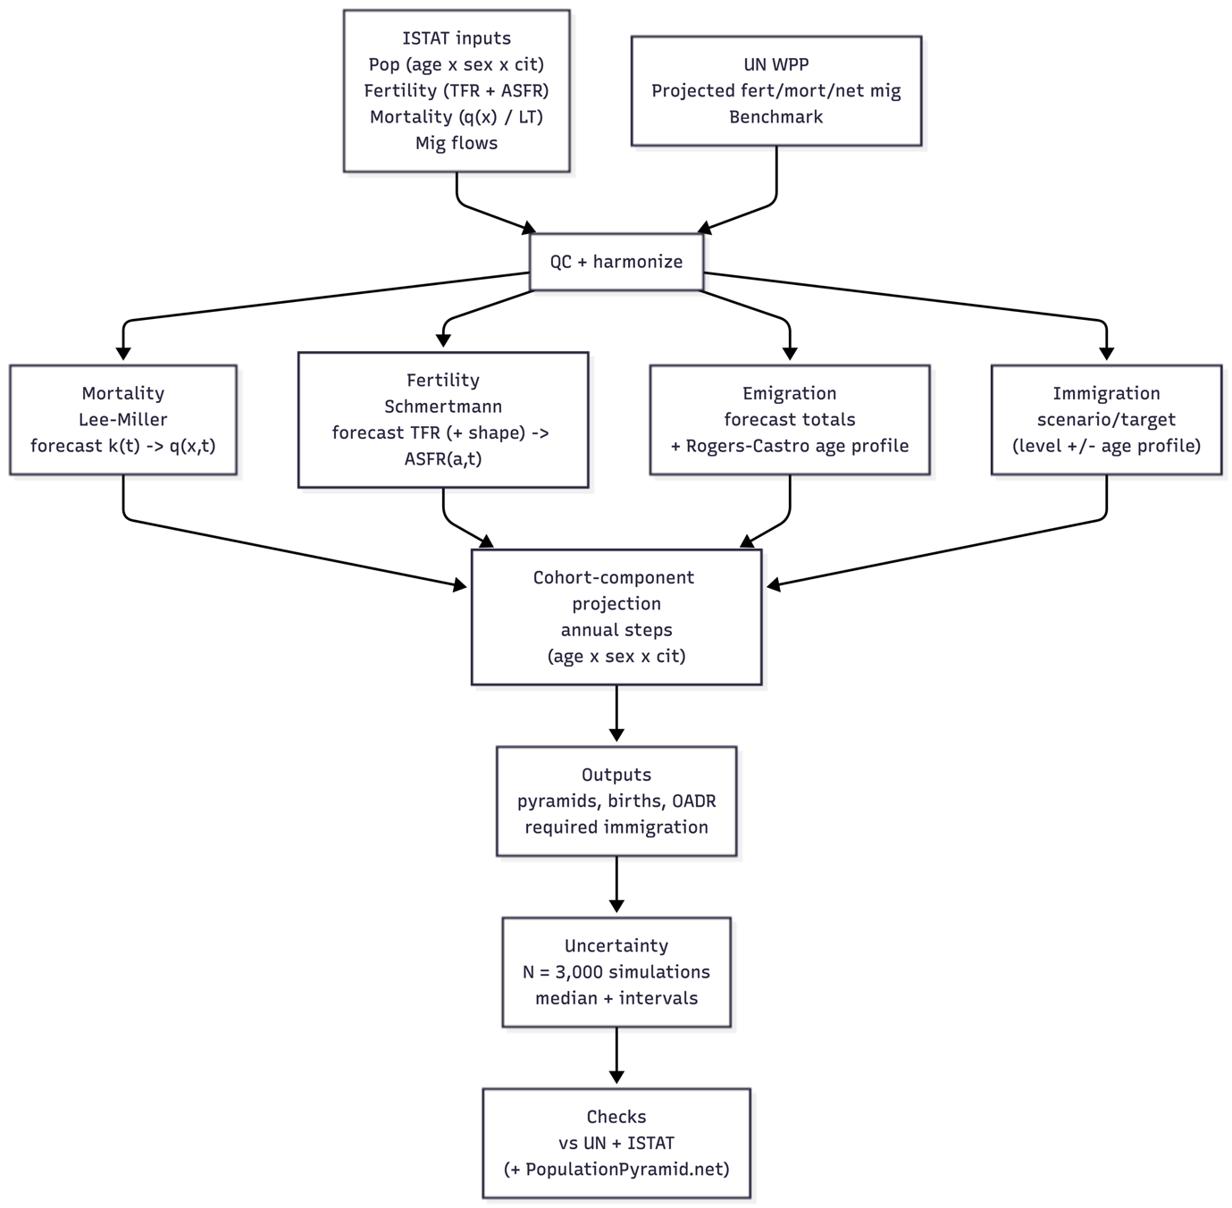
Figure 1: Methodology framework

4. Data: ISTAT and UN Inputs, and What They Provide
This section clarifies which inputs are used for the projection pipeline and what each external source contributes. ISTAT is the main source for constructing inputs that can be split by age, sex, and, where available, citizenship/origin. UN WPP is used mainly as an external benchmark for aggregate trends and uncertainty framing.

4.1 ISTAT
ISTAT provides the key national demographic inputs used to build the projection system: baseline population by single year of age and sex, population split by origin/citizenship, fertility data including births and age-specific fertility patterns, mortality by age and sex, and observed immigration and emigration flows.
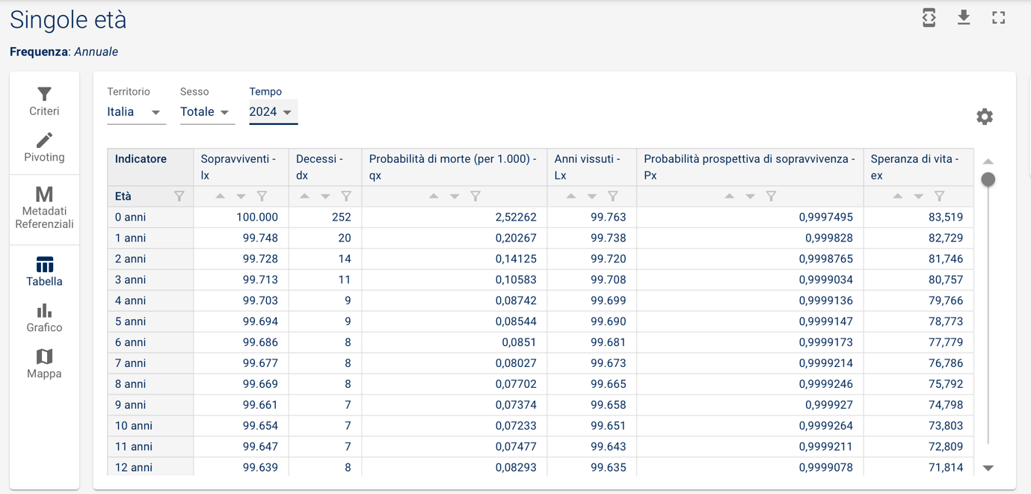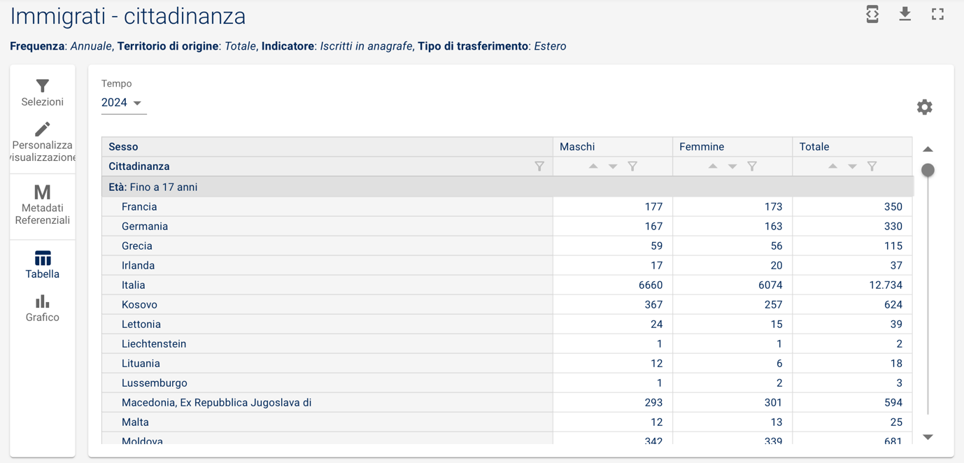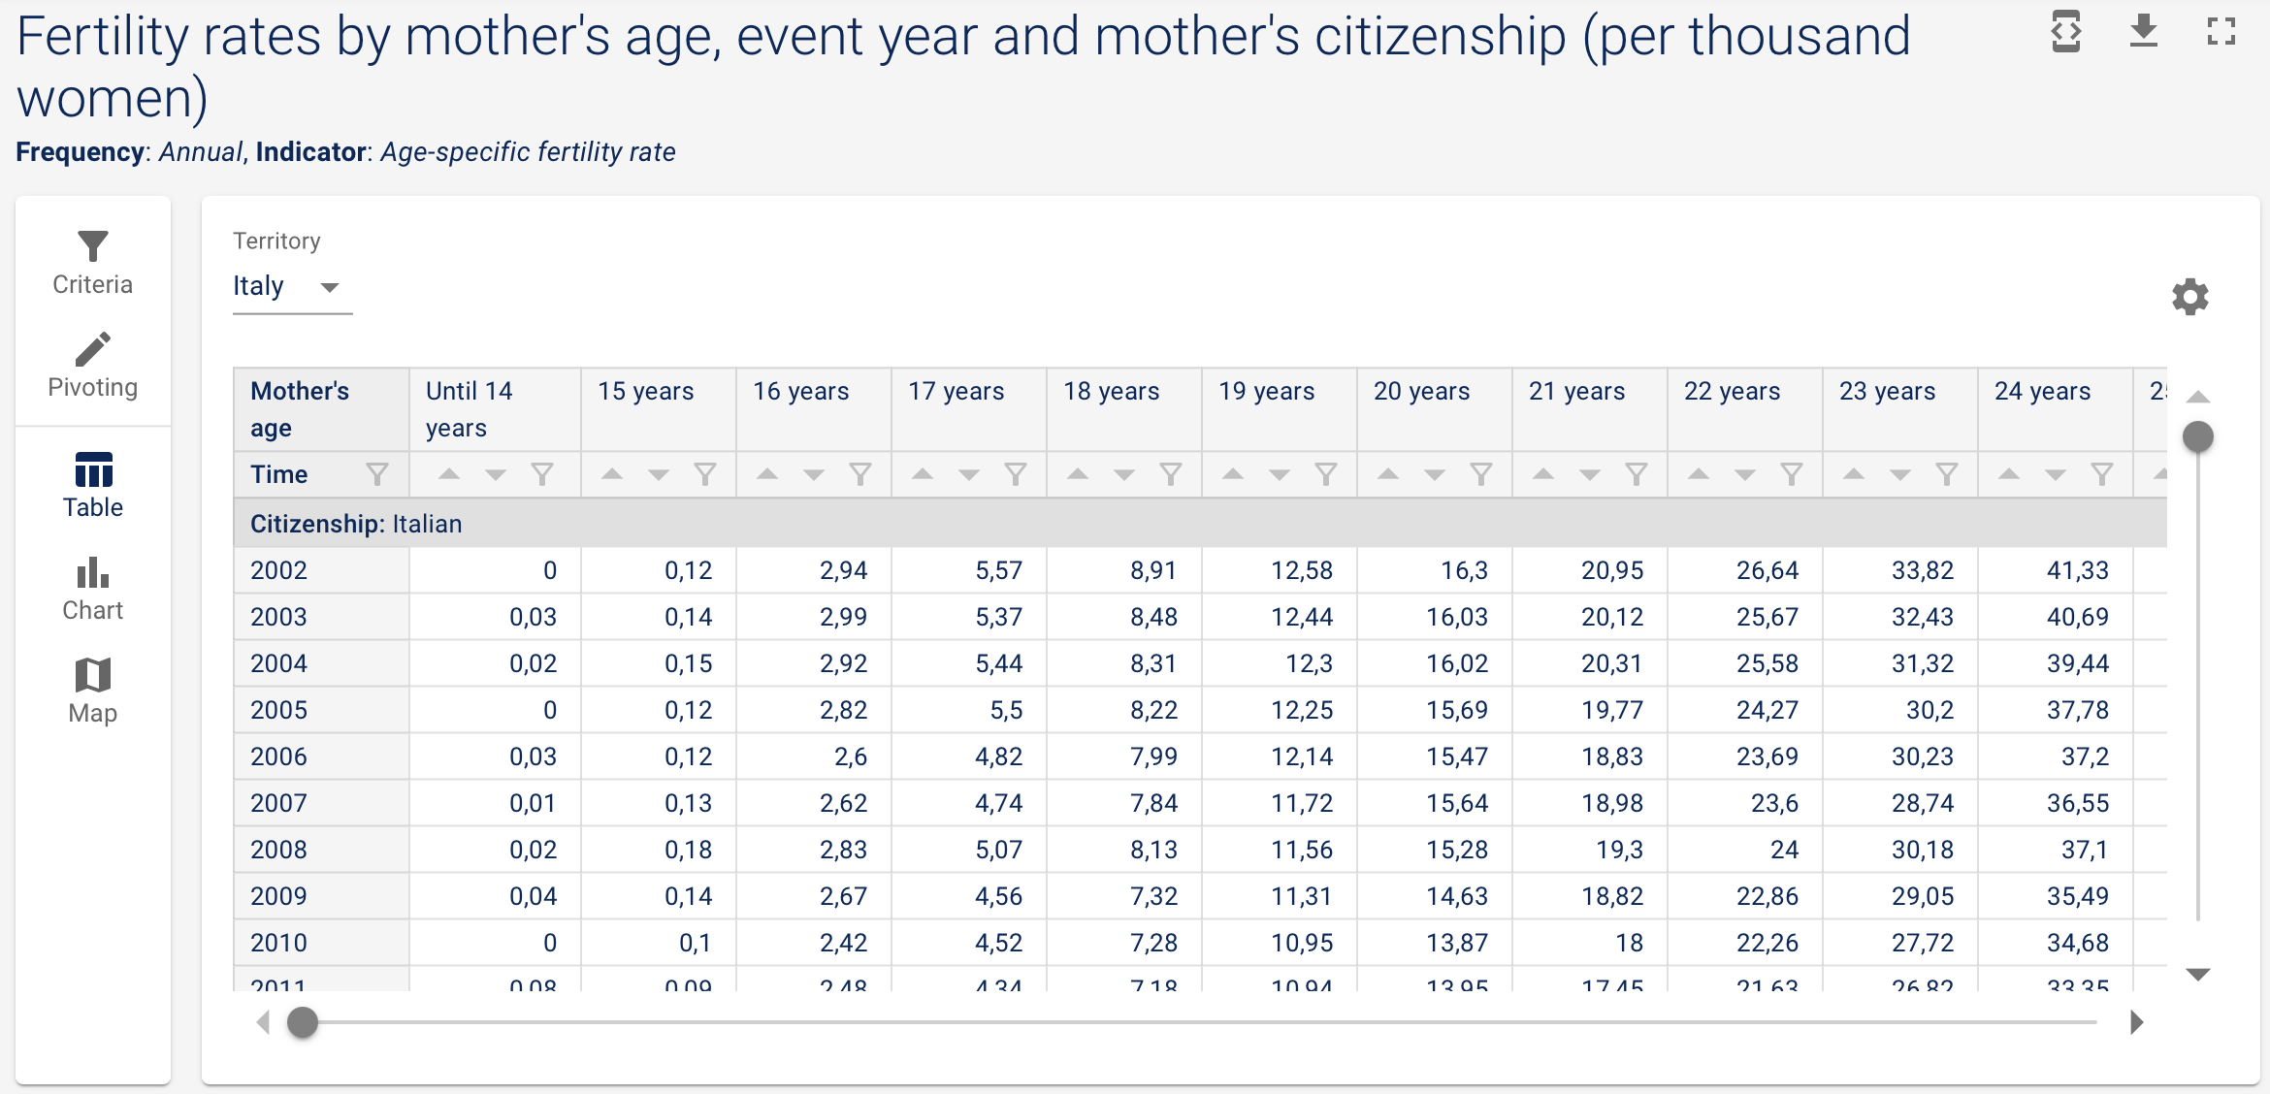
Figure 2: Istat dataset on fertility
Figure 3: Istat dataset on mortality
Figure 4: Istat dataset on migrations
Where the input files contain citizenship or origin distinctions, the model preserves them and uses them in the cohort-component projection.
For migration, the input files contain observed migration counts by broad age range. These are reconstructed into single ages using the age-profile logic described above. This allows the projection to operate at the single-age level while remaining consistent with the observed broad age-band totals.

4.2 UN Data (World Population Prospects)
UN WPP data are used as external comparisons rather than as the main engine of the projection. The relevant UN information includes projected population totals, fertility trajectories, life expectancy paths, and net migration trajectories. In the Streamlit app, UN comparison data can be displayed alongside our projection to help users evaluate whether the internally generated paths are plausible relative to a major international benchmark.
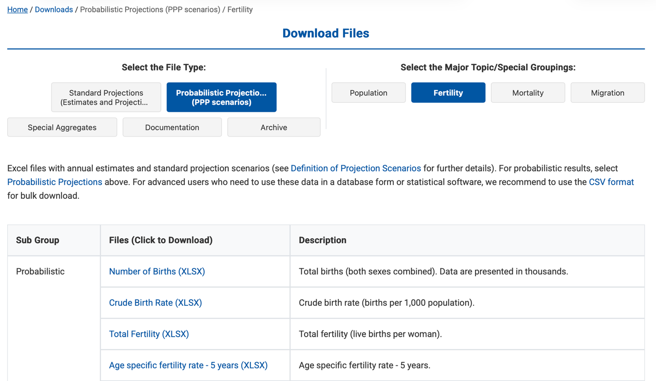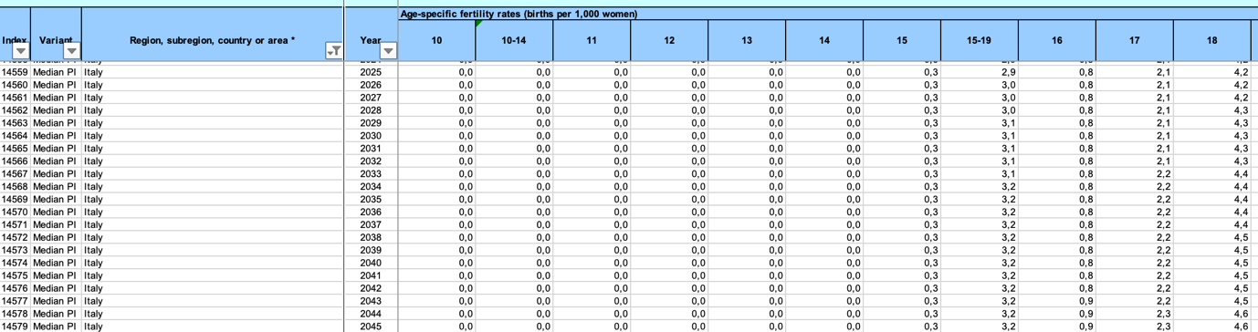
Figure 5: UN WPP Database
Figure 6: UN dataset on forecasted fertility

5. Results
The results of the project are presented primarily through the Streamlit application rather than through a fixed set of static figures. This choice is intentional. The central object of the project is not a single population forecast, but a policy simulator: the relevant question is how Italy’s demographic trajectory changes when assumptions on fertility, mortality, immigration levels, and the age structure of migrants are modified.
The application produces a set of core demographic outputs. These include projected total population with uncertainty bands, population pyramids for selected years, annual births, the old-age dependency ratio, total fertility rate, life expectancy at birth by sex, immigration and emigration flows, net migration, and reverse-policy outputs showing the additional annual immigration required to reach a selected population or OADR target.
A first key result concerns the structural nature of Italy’s demographic decline. The baseline projection confirms the demographic pressure created by low fertility and population ageing. In addition, the simulator includes an intentionally optimistic fertility stress-test scenario, where the projected TFR rises to values that exceed the upper uncertainty bounds of the official comparison sources. This scenario should not be interpreted as our most credible forecast. Rather, it is included to test whether a very favorable fertility trajectory, taken alone, would be enough to prevent population decline. The result is informative: even under this deliberately optimistic assumption, total population still declines over the projection horizon.
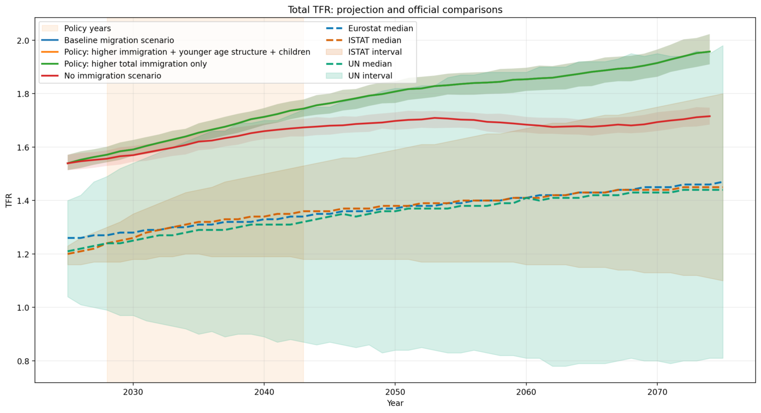
Figure 7: TFR under unlikely high scenario
This supports one of the main points of the project: Italy’s demographic challenge is not only linked to how many children each woman has, but also to how many potential parents there will be in the population. Given the current age structure, fertility recovery alone is unlikely to fully offset depopulation.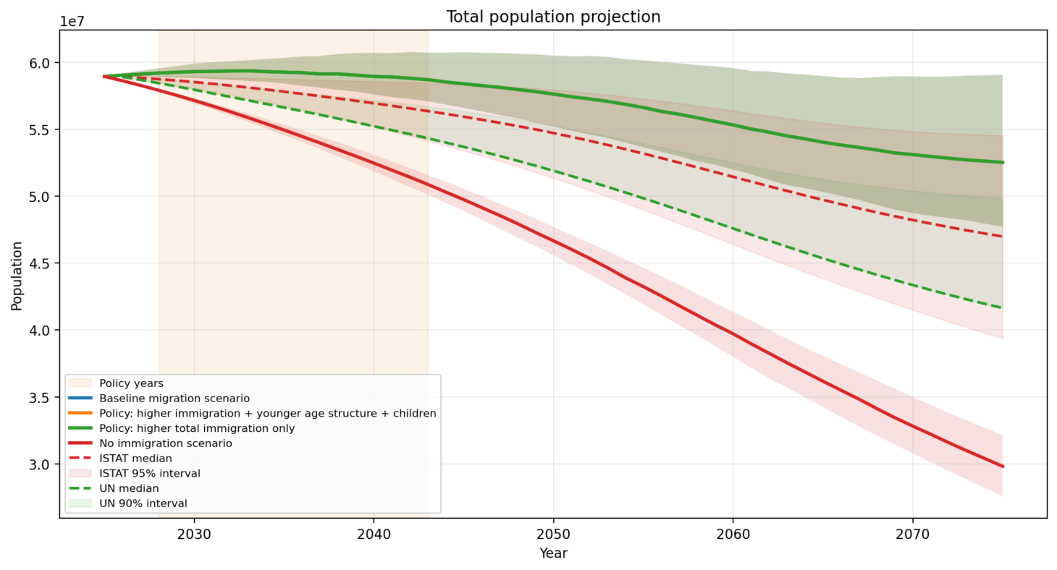
Figure 8: Resulting population under unlikely high TFR
The no-immigration counterfactual is also informative. It is not intended as a realistic policy scenario, but as a diagnostic benchmark. By removing immigration while keeping the other demographic components active, the model shows how strongly future population size and age structure depend on migration. The resulting trajectory highlights the role of migration in slowing depopulation and limiting the worsening of dependency ratios.
The policy scenarios show that the number of immigrants is not the only relevant parameter. The age structure of inflows matters. Additional immigrants concentrated at younger adult ages, especially when combined with children and family migration, have stronger long-term demographic effects than the same number of immigrants distributed according to the baseline age profile. This occurs because younger migrants contribute not only to total population size, but also to the working-age population and, indirectly, to future births.
This point is especially important for the old-age dependency ratio. Keeping the OADR low is not only a matter of increasing the total number of immigrants. It also requires policies that take into account the age composition of inflows. A migration scenario that adds population without considering age may help sustain total numbers, but it can be less effective in improving the balance between working-age and older-age groups. By contrast, inflows concentrated in young adult ages have a stronger effect on the denominator of the OADR and can therefore slow the increase in dependency more effectively. This suggests that, for ageing-related policy goals, migration policy should be evaluated not only by volume, but also by demographic composition.
The reverse-policy tool provides the most direct policy interpretation. Instead of asking only “what happens if immigration increases?”, the application allows the user to ask “how much additional immigration would be needed to reach a specific demographic target?” This turns the projection into a decision-support instrument: targets such as a desired population size or a maximum OADR can be translated into annual additional migration requirements under alternative assumptions about migrant age structure.
Scenario | Target year & OADR | Required + imm x year | Total + imm policy | Policy years | Status
Policy: higher total immigration only | 2075 & 68 | x | 30000000 | 15 | Not reached below 2,000,000 extra immigrants/year
Policy: higher immigration + younger age structure + children | 2075 & 68 | 91171 | 1367567 | 15 | Solved
Table 3: Example of additional annual immigration required to reach a selected target
Overall, the results suggest that immigration policy can substantially affect Italy’s demographic trajectory, but its impact depends on timing, scale, and composition. Fertility recovery remains important, but the projections show that even very favorable fertility assumptions are unlikely to be sufficient on their own, given Italy’s current age structure. Policies focused only on aggregate migration numbers are therefore less informative than policies that also consider age, family structure, integration, and long-term residence. For this reason, the Streamlit application is used as the main results interface: it allows stakeholders to explore these mechanisms directly and transparently.

6. Streamlit
The Streamlit application is the operational interface of the project. It allows the user to select the forecast start year, choose the mortality fitting option, modify TFR assumptions separately for Italians and foreigners, define policy years, set the number of additional immigrants, select the target age range for policy migrants, choose the child share of additional migrants, toggle official comparisons, and download CSV outputs.
The app also includes the reverse-policy game. The user can enter a desired total population or OADR in a selected target year, and the tool returns the annual additional immigration required under the two policy scenarios. This makes the policy question concrete and transparent.
The application can be accessed via the following link: https://bocconi-itapopproj-ab-nc-ds-gc.streamlit.app/, and a demonstration video of its functionality is available here: https://drive.google.com/file/d/1G5wsrnuSGMd7JF9EUo9Ic4ir7QURK0Pk/view?usp=drive_link
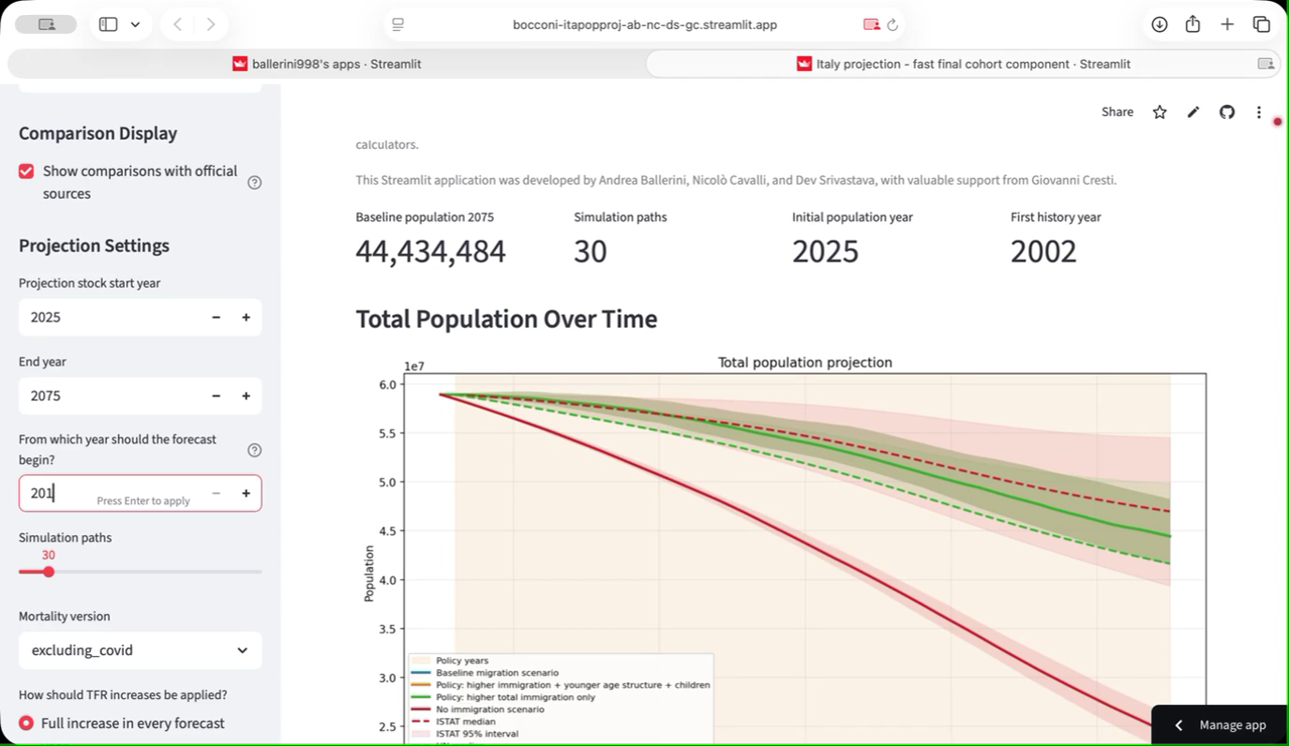
Video 1: Streamlit Application

7. Spin-Offs (TBD)
The demographic projection can be used as the base for economic and social extensions. On the economic side, projected age structures and dependency ratios can feed simulations of labour supply, pension expenditure, health expenditure, education demand, and tax-base dynamics under alternative migration policies.
On the social side, projections can be linked to integration and citizenship policy scenarios. This matters because immigration is not only an inflow but also a long-term process involving residence duration, naturalization, family formation, labour-market integration, school participation, and social inclusion.
A major future development is to obtain more granular data by citizenship, country of birth, legal status, duration of stay, and naturalization pathway. With these data, the model could distinguish groups with different fertility patterns, emigration risks, labour-market profiles, and integration trajectories. This would make the economic and social spin-offs substantially more informative for policy.
A further development is regionalization. National projections are useful for strategic discussion, but many policy questions are territorial: schools, housing, labour-market matching, health services, and integration capacity vary strongly across regions and municipalities.

8. References
Lee, R. D., & Carter, L. R. (1992). Modeling and forecasting U.S. mortality. Journal of the American Statistical Association, 87(419), 659-671. https://doi.org/10.1080/01621459.1992.10475265
Lee, R. D., & Miller, T. (2001). Evaluating the performance of the Lee-Carter method for forecasting mortality. Demography, 38(4), 537-549. https://doi.org/10.1353/dem.2001.0036
Raftery, A. E., Chunn, J. L., Gerland, P., & Sevcikova, H. (2013). Bayesian probabilistic projections of life expectancy for all countries. Demography, 50, 777-801. https://doi.org/10.1007/s13524-012-0193-x
Schmertmann, C. P. (2003). A system of model fertility schedules with graphically intuitive parameters. Demographic Research, 9(5), 81-110. https://doi.org/10.4054/DemRes.2003.9.5
Alkema, L., Raftery, A. E., Gerland, P., Clark, S. J., Pelletier, F., Buettner, T., & Heilig, G. K. (2011). Probabilistic projections of the total fertility rate for all countries. Demography, 48(3), 815-839. https://doi.org/10.1007/s13524-011-0040-5
Azose, J. J., & Raftery, A. E. (2015). Bayesian probabilistic projection of international migration. Demography. https://doi.org/10.1007/s13524-015-0415-0
Rogers, A., & Castro, L. J. (1981). Model Migration Schedules. IIASA Research Report RR-81-030. https://pure.iiasa.ac.at/1543
ISTAT. Previsioni della popolazione residente e delle famiglie: nota metodologica and official projection outputs.
United Nations, Department of Economic and Social Affairs, Population Division. World Population Prospects 2024: Methodology and data files.

